STANDARDS PUBLICATION NO. MFMA-4

METAL FRAMING
STANDARDS PUBLICATION
2004 Revision

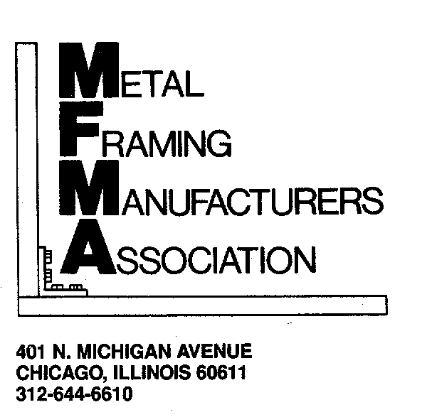
www.metalframingmfg.org
©Metal Framing Manufacturers Association 2004
All Rights Reserved
$5.00

FORWARD

This Standards Publication provides practical information concerning the design, test, and manufacture of metal framing (continuous slot metal channel systems). It provides guidelines for the manufacture of reliable products.

This Standards Publication represents the results of years of research, investigation, and experience by the members of the Metal Framing Manufacturers Association (MFMA). It has been developed through continuing consultation among manufacturers, users, and national engineering societies and is intended to improve serviceability and safety.

This Standards Publication addresses the design, test, and manufacture of Metal Framing System components over which the manufacturer has control. The safety of the total system also involves the system designer, installer, and user. The manufacturer has limited or no control over factors such as: environmental conditions, total system design, product selection and application, installation practices, and system maintenance. Consequently, MFMA disclaims all warrantees, express and implied, associated with this Standards Publication. This Standards Publication has been developed with a view towards promoting safety to persons and property when the Metal Framing System is properly selected, used, and installed according to Article 384 of the National Electrical Code. The products referenced in this publication normally comply with the requirements of Underwriters Laboratory Standard UL5B.

This Standards Publication has been developed in the public interest and is intended to promote a better understanding between the manufacturer and the purchaser. It is intended to assist the purchaser in selecting and obtaining the proper product for a particular need. This is a voluntary standard and does not, in any respect, preclude any member or non-member from manufacturing or selling products not conforming to the standard.

This Standards Publication will be reviewed and updated periodically. MFMA will continue to welcome written comments from interested parties at any time. All such comments should be addressed to:

Mr. Jack M. Springer, Executive Director
Metal Framing Manufacturers Association
401 N. Michigan Avenue
Chicago, IL 60611-4267
Phone: 312.644.6610
Fax: 312.321.4098
For more information, please contact:
mfma@smithbucklin.com

SCOPE

The requirements given in this publication apply to design, test, and manufacture of ferrous and nonferrous metal framing (continuous slot met channel systems) which consist of channels with in-turned lips and associated hardware for fastening to the channels (Strut) at random points.

TABLE OF CONTENTS

FORWARD -i-

SCOPE -ii-

SECTION 1 DEFINITIONS 1

SECTION 2 DESIGN DATA 3
Structural Design 3
Dimensional Data 3
Channel Properties 3
Maximum Design Stress 4
Load Tables 4
Safety Factors 5
Application Data 5

SECTION 3 MATERIALS 6
Channel 6
General Fittings and Accessories 6
Fasteners 7

SECTION 4 FINISHES 8
Metallic Coatings 8
Nonmetallic Coatings 9
Combination Coatings 9
Underwriters Laboratories Listed Items 9

SECTION 5 TOLERANCES 10
Channel, Steel (Roll-Formed) 10
Channel, Aluminum (Extruded) 12
Fittings and Accessories, Steel and Aluminum (Fabricated) 14
Fittings and Accessories, All Sand Cast Metals 14
Fittings and Accessories, All Die Cast Metals 14

SECTION 6 FASTENERS AND THREADS 15

SECTION 7 WELDING 16

SECTION 8 MARKING 17
Channel and Closure Strip 17
General Fittings, Accessories, and Fasteners 17
Steel Straps for Copper Tubing 17
Underwriters Laboratories Marking 17
Alternate Marking Requirements 17

TABLE OF CONTENTS

SECTION 9 TESTING AND INSPECTION 18
Testing – General Fittings, Accessories, and Hardware 18
Slip Test on Channel Nut 19
Pullout Test of Channel Nut 20
Pullout Test – Clamp (Strap) From Channel 21
Slip Test – Clamp (Strap) Along Channel 23
Slip Test – Conduit, Pipe, or Tubing Through Clamp (Strap) 24
Fitting Load Test 26
Cantilever Load Test 28
Concrete Insert Pullout Test 29
Inspection 30

APPENDICES

A – BIBLIOGRAPHY OF SOURCES -v-

B – MEMBER COMPANIES –
METAL FRAMING MANUFACTURERS ASSOCIATION -vi-

SECTION 1
DEFINITIONS

1.1 CHANNEL (STRUT)

The term channel (strut) as used within this standard refers to continuous slot channel (strut) with inturned lips. Multiple channel configurations can be fabricated from single channels.

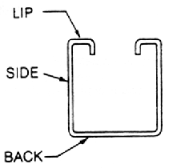
PROFILE OF TYPICAL METAL FRAMING CHANNEL
Figure 1

1.2 CHANNEL NUT

Channel nuts are designed to provide a secure means of attachment when positioned in the continuous slot of a channel.

The nut is formed or stamped in a way that resists slipping along the channel lips after tightening. See Figure 2.

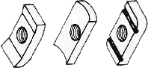

TYPICAL CHANNEL NUTS
Figure 2

1.3 CONCRETE INSERT CHANNEL

A concrete insert channel is a channel having formed or attached anchors, which will support the insert within hardened concrete. This provides means for attachment at random points along the continuous slot.

1.4 ELECTRICAL ACCESSORIES & FITTINGS

Electrical Accessories & Fittings are those items that:

a.) facilitate the use of metal framing channel as electrical raceways and/or,

b.) are utilized to attached, support, or hang electrical materials to or from metal framing components.

1.5 ELECTROPLATING

In this process a ductile coating of zinc is applied by electro-deposition.

1.6 FASTENERS

Fasteners consist of items such as screws, bolts, hex and square nuts, washers, and lock washers. Channel nuts are defined under 1.2.

1.7 GENERAL FITTINGS

General fittings are those which are attached to channels to form a rack, frame, or continuous run of channel.

1.8 HOT DIP GALVANIZING AFTER FABRICATION

In this process, a zinc coating is applied to a cleaned and fluxed surface by dipping into a molten zinc solution. Hot dip galvanizing after fabrication is performed on steel framing and system components after all cold working, cutting, punching, or welding is complete.

1.9 IN LINE HOT GALVANIZING

In this process, a molten zinc solution is deposited on a cleaned surface in a continuous manner during the cold forming operation.

1.10 MECHANICAL ACCESSORIES & FITTINGS

Mechanical accessories & fittings are those items used to support, attach, or hang materials for plumbing, heating, cooling, power, and process piping.

1.11 MILL GALVANIZED BEFORE FABRICATION OR PRE-GALVANIZING

“Mill galvanizing” or “Pre-galvanizing” is the application of zinc on steel sheets or coils in a continuous hot dip process prior to cold working, cutting, punching, or welding of the steel.

SECTION 2
DESIGN DATA

2.1 STRUCTURAL DESIGN

Metal framing structural supports shall be designed in accordance with the following standards:

- AISI “Specification for the Design of Cold-Formed Steel Structural Members”, latest edition.

- The Aluminum Association “Aluminum Construction Manual, Section 1, Specifications for Aluminum Structures”, latest edition.

  - DIMENSIONAL DATA

Dimensional data for channel and fittings published by the manufacturer should include:

- Material thickness
- Length
- Width
- Depth
- Size or location – holes and slots
- Thread sizes
- Concrete inserts – anchor type, size, and spacing

  - CHANNEL PROPERTIES

The manufacturer’s design data for channels should include:

- Moment of inertia (I) – xx and yy axis
- Section modulus (S) – xx and yy axis
- Radius of gyration (r) – xx and yy axis
- Cross sectional area of channel
- Weight per foot

The moment of inertia (I), section modulus (S), radius of gyration (r), and cross sectional area of channel shall be based upon the full cross section of the channel (or net section when applicable), except when the use of a reduced cross section is required by the AISI “Specification for the Design of Cold-Formed Steel Structural Members”, latest edition.

The uncoated minimum steel thickness of the cold formed channel, as delivered, shall not be less than 95% of the thickness used in its design; however, thickness may be less at bends such as corners due to cold forming effect.

2.4 MAXIMUM DESIGN STRESS

2.4.1 The maximum design stress, in bending, recommended for metal framing sections formed from low carbon steel (0.25% or less), is 25,000 pounds per square inch (PSI). This is based upon a virgin steel minimum yield stress of 33,000 PSI cold worked to an average yield stress of 42,000 PSI.

2.4.2 The maximum design stresses of aluminum sections will be found in the Aluminum Association “Aluminum Construction Manual, Section 1, Specifications for Aluminum Structures”, latest edition.

2.4.3 In some applications, reductions in the maximum recommended design stress may be required by applicable standards and/or codes which govern the design for that particular application. Examples of these standards can be found in sub-sections 2.1 and 2.7.

2.5 LOAD TABLES

2.5.1 Beams & Columns

Load data published by the manufacturers for metal framing beams and columns shall be based upon calculations and should include:

a) Maximum uniform load on a laterally braced simple span as permitted by the design procedures in the AISI “Specification for the Design of Cold-Formed Steel Structural Members”, latest edition.

b) Uniform load on a laterally braced simple span that causes a deflection equal to 1/240 multiplied by the length of the span in inches, provided the load does not exceed that computed in item ‘a’.

c) Maximum deflection caused by the beam loading computed in item ‘a’.

d) Maximum axial load on columns as permitted by the design procedures in the AISI “Specification for the Design of Cold-Formed Steel Structural Members”, latest edition.

2.5.2 General Fittings, Accessories, and Fasteners

Load data published by the manufacturers for general fittings, accessories, and fasteners shall be based upon tests of standards products and should include:

a) Slip resistance of channel nuts in continuous slot opening.
b) Pull-out resistance of channel nuts in continuous slot opening.
c) Bracket load data.
d) Fitting and accessory load data, where applicable.
e) Concrete insert pullout load data.

2.6 SAFETY FACTORS

2.6.1 The manufacturer’s published data for maximum design load will normally include a safety factor. The safety factor, unless otherwise noted, is the ratio of the ultimate load to the maximum design load.

2.6.2 For static loads, a minimum safety factor of three (3) is recommended. In addition, harmful distortion of a particular component or assembly should not occur at a load less than the maximum design load multiplied by 1.68.

2.6.3 For some applications, increases in the minimum safety factor may be required by applicable standards and/or codes, which govern the design of that particular application. Examples of these standards can be found in Sections 2.1 and 2.7.

2.7 APPLICATION DATA

2.7.1 Electrical Data

2.7.1.1 Metal framing for use as an electrical raceway shall meet the requirements of:

a) Underwriters Laboratories, Inc. “Standard for Strut-Type Channel Raceways and Fittings”, UL5B.

- “National Electrical Code”, ANSI/NFPA 70- NEC Article 384

      - Electrical data published by the manufacturer should include:

a) Underwriters Laboratories, Inc. listing information, including conductor fill and cubic inch capacity of outlet boxes.

b) Knockout size and spacing.

2.7.2 Piping Support Data

Where applicable, systems used to support piping should be designed in accordance with the American National Standard Code for Pressure Piping “Power Piping”, ANSI/ASME B31.1.

SECTION 3
MATERIALS

3.1 MATERIALS

The material used in the manufacture of metal framing systems shall meet the requirements of the following Standards as applicable.

This specification is intended to cover ferrous and nonferrous base materials. Materials used in finishing, coating, and other secondary processes shall be addressed in specific specifications. Material specifications include, but are not limited to the following:

3.1.1 Channel*

ASTM A167 Stainless and Heat Resisting Chromium-Nickel Steel Plate, Sheet and Strip.

Same line, two different revisions:
ASTM A240/A240M Heat-resisting Chromium and Chromium-Nickel Steel Plate, Sheet and Strip for Fusion Welded Unfired Pressure Vessels.

ASTM A240/A240M Heat-resisting Chromium and Chromium-Nickel Steel Plate, Sheet and Strip Pressure Vessels.

ASTM A1008/ Steel, Carbon, Cold-Rolled Sheet, Commercial Quality
A1008M

ASTM A366/ Steel, Sheet, Carbon, Cold-Rolled, Commercial Quality
A366M

ASTM A1011/ Steel, Carbon (0.15 maximum percent), Hot-Rolled Sheet and A1011M Strip Commercial Quality.

ASTM A1011/ Steel, Sheet and Carbon-Stripped, Hot-Rolled, Structural
A1011M Quality.

ASTM A1008/ Steel, Sheet, Carbon, Cold-Rolled, Structural Quality.
A1008M

ASTM A653/ Steel, Sheet, Zinc-Coated (galvanized) by the Hot-Dip Process.
A653M

ASTM A659/ Steel, Carbon (0.16 maximum to 0.25 maximum percent), Hot-
A659M Rolled Sheet and Strip, Commercial Quality.

ASTM B209 Aluminum and Aluminum-Alloy Sheet and Plate.

ASTM B221 Aluminum, Aluminum-Alloy and Extruded Bar, Rods Wire, Profiles and Tube.

*Material standards for channels shall meet the requirements of paragraph 2.4.

When verification of minimum yield stress, before cold-working is required, certification shall be made by one of the following:

a) Steel supplier certified material test report (CMTR).

b) Metal framing manufacturer’s certificate of compliance (C of C) based upon two coupons per heat tested in accordance with ASTM A370-87c.

3.1.2 General Fittings and Accessories

ASTM A36/A36M Carbon, Structural Steel.

ASTM A47/A47 Ferritic Iron Castings.

ASTM A47/A47M Castings, Iron, Ferritic Malleable

ASTM A48/A48M Gray Iron Castings.

ASTM A108 Steel Bars, Carbon, Cold-Finished, Standard Quality.

ASTM A167 Stainless and Heat Resisting Chromium-Nickel Steel Plate, Sheet and Strip.

ASTM A240/ Heat-Resisting Chromium and Chromium-Nickel Stainless Steel
A240M Plate, Sheet and Strip for Pressure Vessels.

ASTM A242/ High-Strength, Low-Alloy Structural Steel.
A242M

ASTM A653/ For Zinc, Iron-Alloyed Coated.
A653M

ASTM A536 Ductile Iron Castings.

ASTM A1011 Steel, Carbon (0.15 maximum percent), Hot-Rolled Sheet and A1011M Strip, Commercial Quality.

ASTM A1011/ Steel Sheet and Strip, Carbon, Hot-Rolled, Structural Quality.
A1011M

ASTM A575 Steel Bars, Carbon, Merchant Quality, M-Grades.

ASTM A576 Steel Bars, Carbon, Hot-Rolled, Special Quality.

ASTM A635/ Steel Sheet, Strip, Heavy Thickness Coil, Carbon, Hot-Rolled.
A635M

ASTM A659/ Steel, Carbon (0.16 minimum to 0.25 maximum percent), Hot-
A659M Rolled Sheet and Strip, Commercial Quality.

ASTM A675/ Steel Bars, Carbon, Hot Wrought, Special Quality, Mechanical
A675M Properties.

Add: ASTM A1018/ Steel, sheet and strip, heavy thickness coils, hot rolled,
1018M carbon, structural.

ASTM B26/B26M Aluminum-Alloy Sand Castings.

ASTM B85 Aluminum-Alloy Die Castings.

ASTM B86 Zinc-Alloy Die Castings.

ASTM B783 Materials for Ferrous Powder Metallurgy (P/M) Structural Parts.

3.1.3 Fasteners

SAE J429 Mechanical and Material Requirements for Externally Threaded Fasteners.

SAE J995 Mechanical and Quality Requirements for Steel Nuts.

ASTM A307 Carbon Steel Bolts, Studs, 65,000 PSI Pencil Straight, Externally Threaded Fasteners.

ASTM A563 Carbon and Alloy Steel Nuts.

ANSI B18.6.2 Slotted Head Cap Screw, Square Head Set Screw, and Slotted Headless Set Screws.

ANSI B18.6.3 Machine Screws and Machine Screw Nuts.

ANSI B18.21.1 Lock Washers.

ANSI B18.22.1 Plain Washers.

SECTION 4
FINISHES

4.1 Framing channel, general fittings, accessories, and hardware may be manufactured with bare metal surfaces or with protective coatings as detailed in the sections below.

4.1.1 Metallic Coatings

a) Electroplated Coatings

Framing channel, general fittings, accessories, and fasteners shall be electroplated in accordance with the following:

ASTM B633 “Electrodeposited Coatings of Zinc on Iron and Steel.”

b) Hot Dip Galvanized After Fabrication

Framing channel, general fittings, accessories, and fasteners shall be hot-dip galvanized in accordance with one of the following:

ASTM A123/ Zinc (Hot-Dipped Galvanized) coatings on Iron and
A123M Steel products.

ASTM A153 Zinc Coating (Hot-Dip) on Iron and Steel Hardware.
A153M

c) Mill-galvanized (Pre-galvanized) Sheet

Galvanized steel sheet used to manufacture pre-galvanized channel or fittings shall be in accordance with the following standard:

ASTM A653/ Steel Sheet, Zinc-Coated (Galvanized) by the Hot-Dip
A653M Process.

Uncoated edges resulting from slitting, punching, and channel cut-off are permitted.

d) In-Line Hot Galvanized

Framing channel may be galvanized by applying a molten zinc coating as part of the continuous cold forming operation.

e) Mechanically Deposited Coatings

General fittings, accessories, and fasteners shall be mechanically coated in accordance with the following:

ASTM B695 Coatings of Zinc Mechanically Deposited on Iron and Steel.

f) Other Metallic Coatings

Channel, general fittings, accessories, and fasteners may be coated with other metallic coatings to meet specific needs. Coatings shall be on surfaces that have been suitably prepared and cleaned. Procedures and coating thickness shall be to recognized standards or customer specifications.

4.1.2 Non-Metallic Coatings

a) Painted Coatings

Paint may be of any type, including vinyl, vinyl-alkyd, epoxy, polyester, acrylic, amine, alkyd, etc.

Paint may be applied by any of the conventional processes including, but not limited to, spraying, brushing, dipping, flow-coating, roller-coating, powder-fusing, electro-depositing, etc. In all cases, the base metal shall be clean and properly prepared to bond with the paint coating.

Architectural finish or maintenance painting may be required.

Framing channel may be formed from prepainted coil or strip. In these cases, uncoated edges resulting from slitting, punching, and channel cut-off are permitted.

b) Anodized Coating

Aluminum channel and fittings, etc., that are anodized shall be coated in accordance with the Aluminum Association “Designation System for Aluminum Finishes AA-A21 Clear Coating Less Than 0.4 mils Thick”.

c) Other Non-Metallic Coatings

Polyvinylchloride (PVC), polyurethane, epoxy, polyester, and other nonmetallic coatings shall be applied by appropriate process to cleaned and prepared metals.

4.1.3 Combination Coatings

Materials that have been metal-coated in accordance with Part 1 of this section may have additional non-metallic coating applied, e.g., galvanized material may be additionally PVC coated.

4.1.4 Underwriters Laboratories Listed Items

All channel materials identified as “Listed by Underwriters Laboratories, Inc.” shall be finished to comply with UL5B “Standard for Strut-Type Channel Raceways and Fittings.”

SECTION 5
TOLERANCES

5.1 CHANNEL, STEEL (ROLL-FORMED)

5.1.1 Wall Thickness (information only)

a) Uncoated steel*

Manufacturer’s  Standard  Gage No. | Equivalent  Thickness,  Inches
20 | .0359
19 | .0418
18 | .0478
17 | .0538
16 | .0598
15 | .0673
14 | .0747
13 | .0897
12 | .1046
11 | .1196
10 | .1345

*See ASTM A568/A568M “Steel Sheet, Carbon and High-Strength Low-Alloy Hot-Rolled and Cold-Rolled, General Requirements,” for steel tolerances. Tolerances for Gages No. 10 through 16 are for Hot-Rolled Sheets and tolerances for Gages No. 17 through 20 are for Cold-Rolled Sheets.

b) Mill Galvanized Steel**

Manufacturer’s  Standard  Gage No. | Equivalent  Thickness,  Inches***
20 | .0374
19 | .0433
18 | .0493
17 | .0553
16 | .0613
15 | .0688
14 | .0762
13 | .0912
12 | .1060
11 | .1211
10 | .1360

**See ASTM A924/A924M “General Requirements for Steel Sheet, Zinc-Coated (galvanized) by the Hot-Dip Process.” Tolerances for Gages No. 10 through 16 are for Hot-Rolled Sheets and tolerances for Gages No. 17 through 20 are for Cold-Rolled Sheets.

***Represents G 90 coating specified in ASTM A653/A653M.

5.1.2 Outside Dimensions*

Solid Sides ± 0.015 inches
Slot Sides ± 0.035 inches

*Outside dimensions are measured at corners at least three (3) inches from the cut end of the section.

5.1.3 Squareness

a) Measured between adjacent planes = ± 1 degree.

b) Measured between adjacent planes on the in-turned portion of the lips = ± 2 degrees.

5.1.4 Twist

0.0125 inch per ft. (i.e., 1/8 inch in 10 ft. length)

NOTE: Twist shall be measured by clamping one end of the channel on a flat surface and noting the height of either corner of the opposite end of the same side above the flat surface.

See Figure 3.

Figure 3

5.1.5 Straightness

a) Fabricated channel shall not deviate from a plane more than the dimensions shown in Figure 4.

Figure 4

b) Fabricated channel i.e., (punched or welded) shall not deviate more than 1/4 inch in 10 ft. length.

5.1.6 Length

± 1/8 inch

5.1.7 End Cuts

± 2 degrees from square

5.2 CHANNEL, ALUMINUM (EXTRUDED)

5.2.1 Wall Thickness

Thickness,  Inches | Tolerance  ±, Inches
0.124 and less | 0.006
Over 0.124 through 0.249 | 0.007

5.2.2 Outside Dimensions

Nominal Outside Dimensions  Inches |  | Tolerance at Corners  ±, Inches
 | Solid Sides |  | Slot Sides
2 and less | 0.015 |  | 0.030
Over 2 through 4 | 0.024 |  | 0.040

5.2.3 Squareness

± 1 degree when measured between adjacent planes.

5.2.4 Twist

0.040 inch in 3 feet.

NOTE: Twist shall be measured by holding one end of channel on a flat surface and noting the height of either corner of the opposite end of the same side above the flat surface.

See Figure 3.

5.2.5 Straightness

a) See Figure 4.

b) Fabricated channel i.e., (punched or welded) shall not deviate more than 1/4 inch in 10 ft. length.

5.2.6 Length

± 1/8 inch

5.2.7 End Cuts

± 2 degrees from square

5.3 FITTINGS AND ACCESSORIES, STEEL AND ALUMINUM (FABRICATED)

5.3.1 Length
± 1/16 inch

5.3.2 Width
± 1/16 inch

5.3.3 Angularity
a) In flat plate = ± 1 degree
b) In formed fittings = ± 2 degrees

5.3.4 Flatness
1/64 inch maximum crown in 3 inches.

5.3.5 Hole
a) Location = ± 1/32 inch
b) Diameter = ± 0.010 inch

5.3.6 Material Thickness

Thickness,  Inches | Tolerance  ±, Inches
1/8 | .014
3/16 | .014
¼ | .030
3/8 | .030

5.3.7 Alignment of Welded Components
± 1/16 inch and ± 2 degrees.

5.4 FITTINGS AND ACCESSORIES, ALL SAND CAST METALS

All “as cast” dimensions, ± 3/64 inch.

5.5 FITTINGS AND ACCESSORIES, ALL DIE CAST METALS
All “as cast” dimensions, ± 0.010 inch.

NOTE: Where two or more tolerances affect the same dimension, the least restrictive shall apply.

The tolerances in this section do not apply to parts hot-dip galvanized after fabrication.

SECTION 6
FASTENERS AND THREADS

6.1 FASTENERS AND THREADS

Fasteners and threads shall meet the applicable requirements of one or more of the following standards:

a) ASTM Standards on Fasteners, Section 15, Volume 15.08, latest edition.

b) SAE Handbook, latest edition.

c) IFI “Fastener Standards”, latest edition.

d) ASME B1.1 “Unified Screw Threads, latest edition.

e) GSA Federal Standard H-28, latest edition.

SECTION 7
WELDING

  - Welds shall meet the performance requirements of the applicable section of AISI “Specification for the Design of Cold-Formed Steel Structural Members”, latest edition.

Deviation from the above specification is permitted when acceptable to the user.

SECTION 8
MARKING

8.1 CHANNEL AND CLOSURE STRIP

The manufacturer’s name or identifying mark shall be displayed legibly on the section or on the package.

8.2 GENERAL FITTINGS, ACCESSORIES, AND FASTENERS

The manufacturer’s name or identifying mark and trade size (where applicable) shall be displayed on each part or assembly or on the package.

8.3 STEEL STRAPS FOR COPPER TUBING

Steel straps sized for copper tubing may be copper-plated or copper-coded for identification purposes in addition to Section 8.2.

8.4 UNDERWRITERS LABORATORIES MARKING

Those parts which are UL-listed shall be marked in accordance with the requirements of any applicable UL Standards, i.e., UL5B, Standard for Strut-Type Channel Raceways & Fittings.

8.5 ALTERNATE MARKING REQUIREMENTS

If a specific method or location of marking is required by the end user, it must be specified on the customer’s order.

SECTION 9
TESTING AND INSPECTION

9.1 TESTING – GENERAL FITTINGS, ACCESSORIES, AND HARDWARE

When physical load testing is required, the provisions of this section shall apply. In general, physical testing shall be performed when:

a) the failure mode is not readily apparent,

b) when calculations involve excessive assumptions,

c) when testing is the most practical approach.

The test procedures described in this part shall be used to establish comparative load ratings for the items indicated. Other tests may be conducted at the option of the manufacturer. The procedures of the following organizations shall be used where applicable:

American Society for Testing & Materials

American Iron & Steel Institute

American Welding Society

Underwriters Laboratories, Inc.

American Society for Non-destructive Testing

9.1.1 Slip Test on Channel Nut
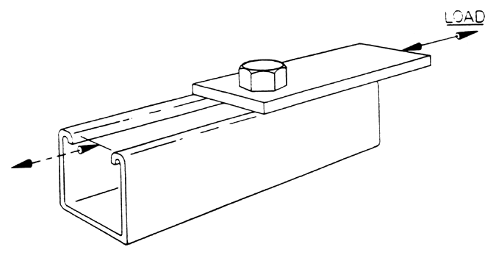

Figure 5

A flat plate fitting shall be connected to the slot opening of a metal framing channel by a single clamping nut and hex head bolt tightened in accordance with the following torques:

Bolt Size,  Inches | Torque  Foot-Pounds *
¼ | 6
5/16 | 11
3/8 | 19
½ | 50

The test load shall be applied to the flat plate fitting parallel to the longitudinal axis of the metal framing channel. See Figure 5.

The rate of loading shall not exceed 1/2 inch per minute.

Slip failure shall be the point of maximum load where slip continues without any increase in the load.

NOTE: This test shall be evaluated in accordance with the applicable section of the AISI “Specification for the Design of Cold-Formed Steel Structural Members”, latest edition.

* Grade 2, UNC threads, non-lubricated.

    - Pullout Test of Channel Nut

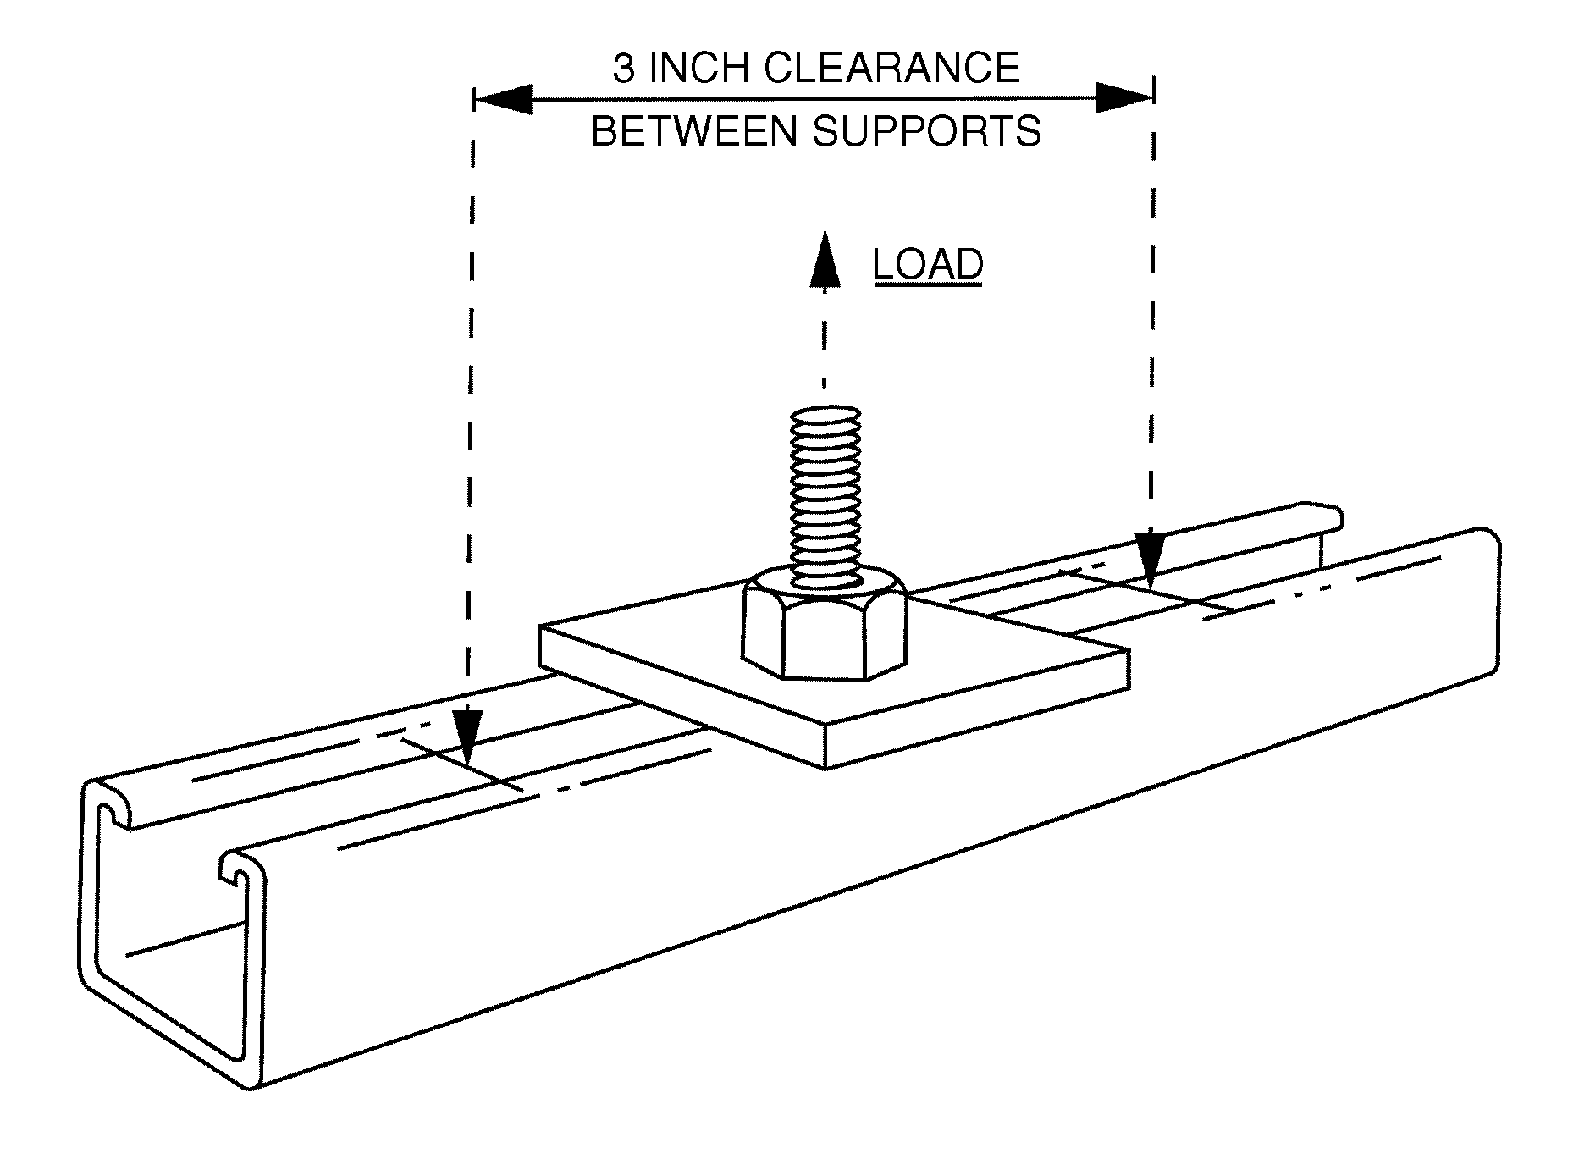

Figure 6

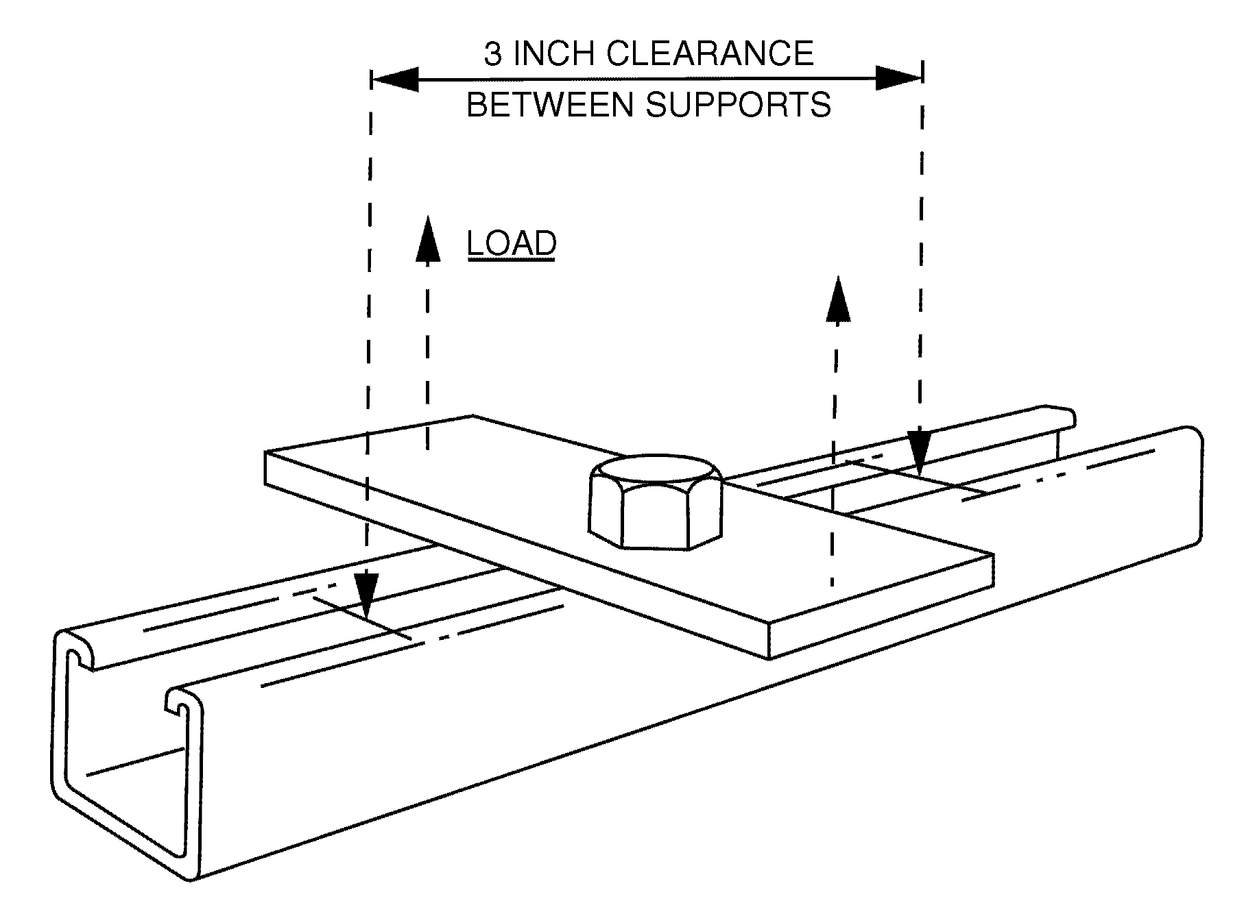

Figure 7

9.1.2 (cont.)

The channel nut shall be inserted into the slot opening of a channel having a minimum length of six (6) inches.

A threaded fastener shall be inserted into the channel nut and secured at the lips of the channel with a flat plate washer and a hex nut or bolt tightened with the torques given in 9.1.1. The channel nut shall be rigidly supported and the test pullout load shall be applied to the threaded fastener perpendicular to the channel as shown in Figures 6 or 7.

Pullout failure shall be the point of maximum load where yielding continues without any increase in the load.

The rate of loading shall not exceed 1/2 inch per minute.

NOTE: This test shall be evaluated in accordance with the applicable section of the AISI “Specification for the Design of Cold-Formed Steel Structural Members”, latest edition.

    - Pullout Test – Clamp (Strap) From Channel

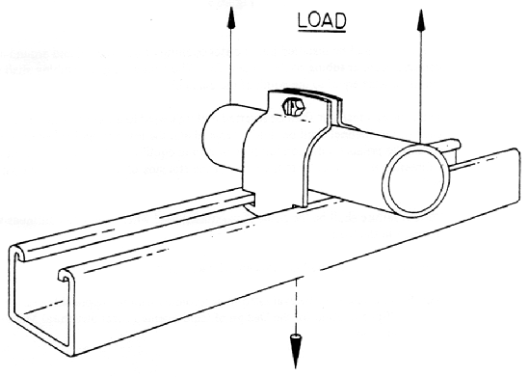
Figure 8

9.1.3 (cont.)
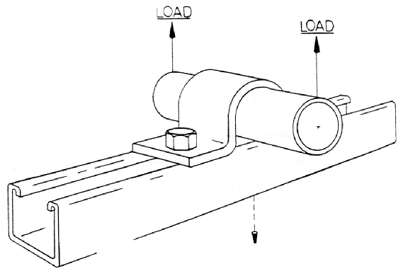
Figure 9

The clamp shall be installed into the slot opening of the channel and around a section of conduit, pipe, or tubing of the proper size. The conduit, pipe, or tubing shall be of a length at least equal to the width of the channel.

The threaded fastener shall be inserted and tightened to a torque as given in 9.1.1. The back of the channel shall be rigidly secured and the test pullout load shall be applied equally to points on the conduit pipe or tubing equidistant from the center of the clamp in a direction perpendicular to the plane of the slot side of the channel as shown in Figures 8 or 9.

Pullout failure shall be the point of maximum load where yielding continues without any increase in the load.

The rate of loading shall not exceed 1/2 inch per minute.

NOTE: This test shall be evaluated in accordance with the applicable section of the AISI “Specification for the Design of Cold-Formed Steel Structural Members,” latest edition.

    - Slip Test – Clamp (Strap) Along Channel
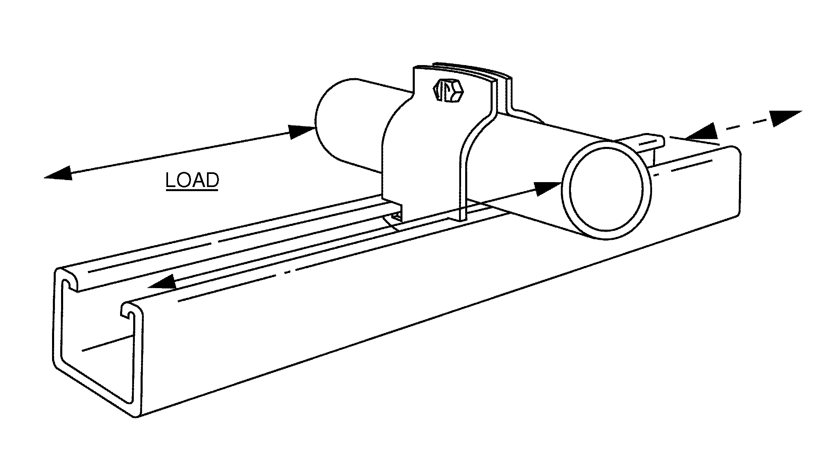

Figure 10

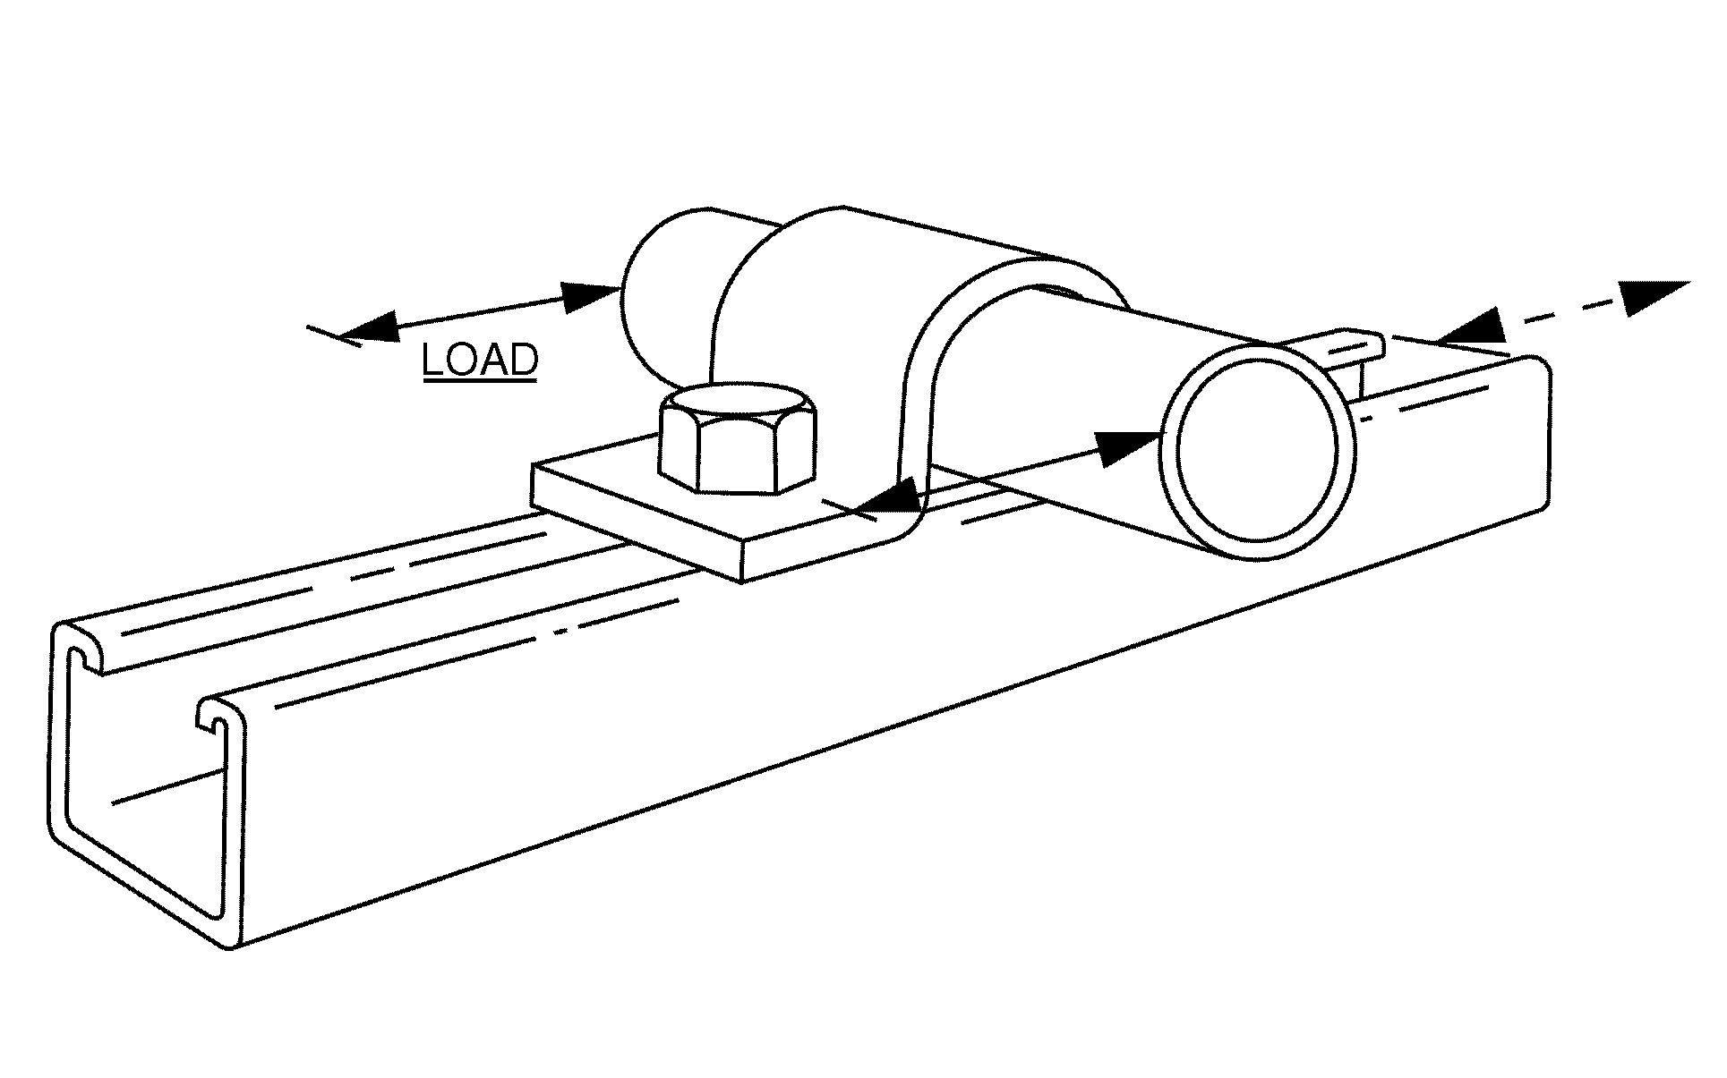

Figure 11

9.1.4 (cont.)

The clamp shall be installed into the slot opening of the channel and around a section of conduit, pipe, or tubing of the proper size. The conduit, pipe, or tubing shall be of a length at least equal to the width of the channel.

The threaded fastener shall be inserted and tightened to a torque as given in 9.1.1.

The back of the channel shall be rigidly secured and the test slip load shall be applied equally to points on the conduit, pipe, or tubing equidistant from the center of the clamp in a direction parallel to the plane of the slot side of the channel as shown in Figure 10 or 11.

Failure shall be the point of maximum load where yielding or slipping continues without any increase in the load.

The rate of loading shall not exceed 1/2 inch per minute.

NOTE: This test shall be evaluated in accordance with the applicable section of the AISI “Specification for the Design of Cold-Formed Steel Structural Members,” latest edition.

    - Slip Test – Conduit, Pipe, or Tubing Through Clamp (Strap)

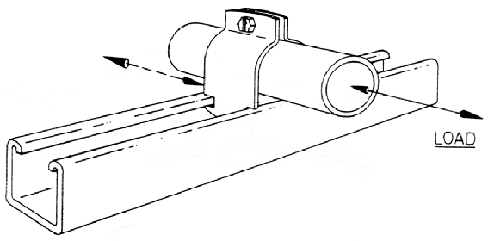

Figure 12

9.1.5 (cont.)

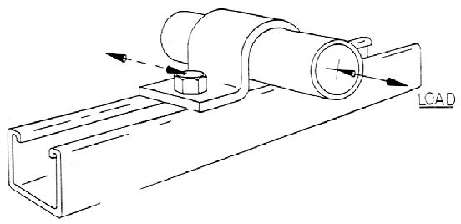
Figure 13

The clamp shall be installed into the slot opening of the channel and around a section of conduit, pipe, or tubing of the proper size. The conduit, pipe, or tubing shall be of a length at least equal to the width of the channel.

The threaded fastener shall be inserted and tightened to a torque as given in 9.1.1.

The channel shall be rigidly secured and the test load shall be applied axially to the conduit, pipe, or tubing as shown in Figures 12 or 13.

Failure shall be the point of maximum load where yielding or slipping continues without any increase in the load.

The rate of loading shall not exceed 1/2 inch per minute.

NOTE: This test shall be evaluated in accordance with the applicable section of AISI “Specification for the Design of Cold-Formed Steel Structural Membership,” latest edition.

    - Fitting Load Test
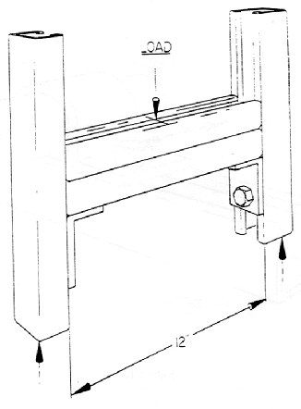

Figure 14

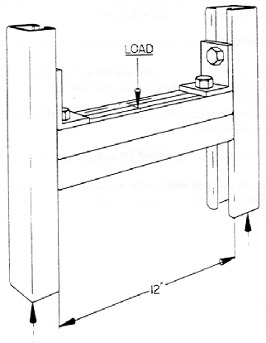
Figure 15

9.1.6 (cont.)

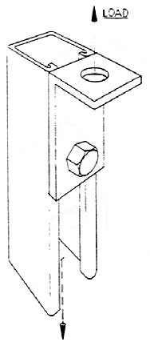
Figure 16

The fitting shall be attached to the slot opening of the channel.

The threaded fasteners shall be inserted and tightened to a torque as given in 9.1.1.

The channel shall be rigidly secured top and bottom and the test load shall be applied to the fitting(s) as shown in Figures 14, 15, and 16.

Failure shall be the lesser of either the point of maximum load where yielding or slipping continues without any increase in the load or where distortion of the part becomes so great as to render the proper performance impossible.

The rate of loading shall not exceed 1/2 inch per minute.

NOTE: This test shall be evaluated in accordance with the applicable section of the AISI “Specification for the Design of Cold-Formed Steel Structural Members,” latest edition.

9.1.7 Bracket Cantilever Load Test

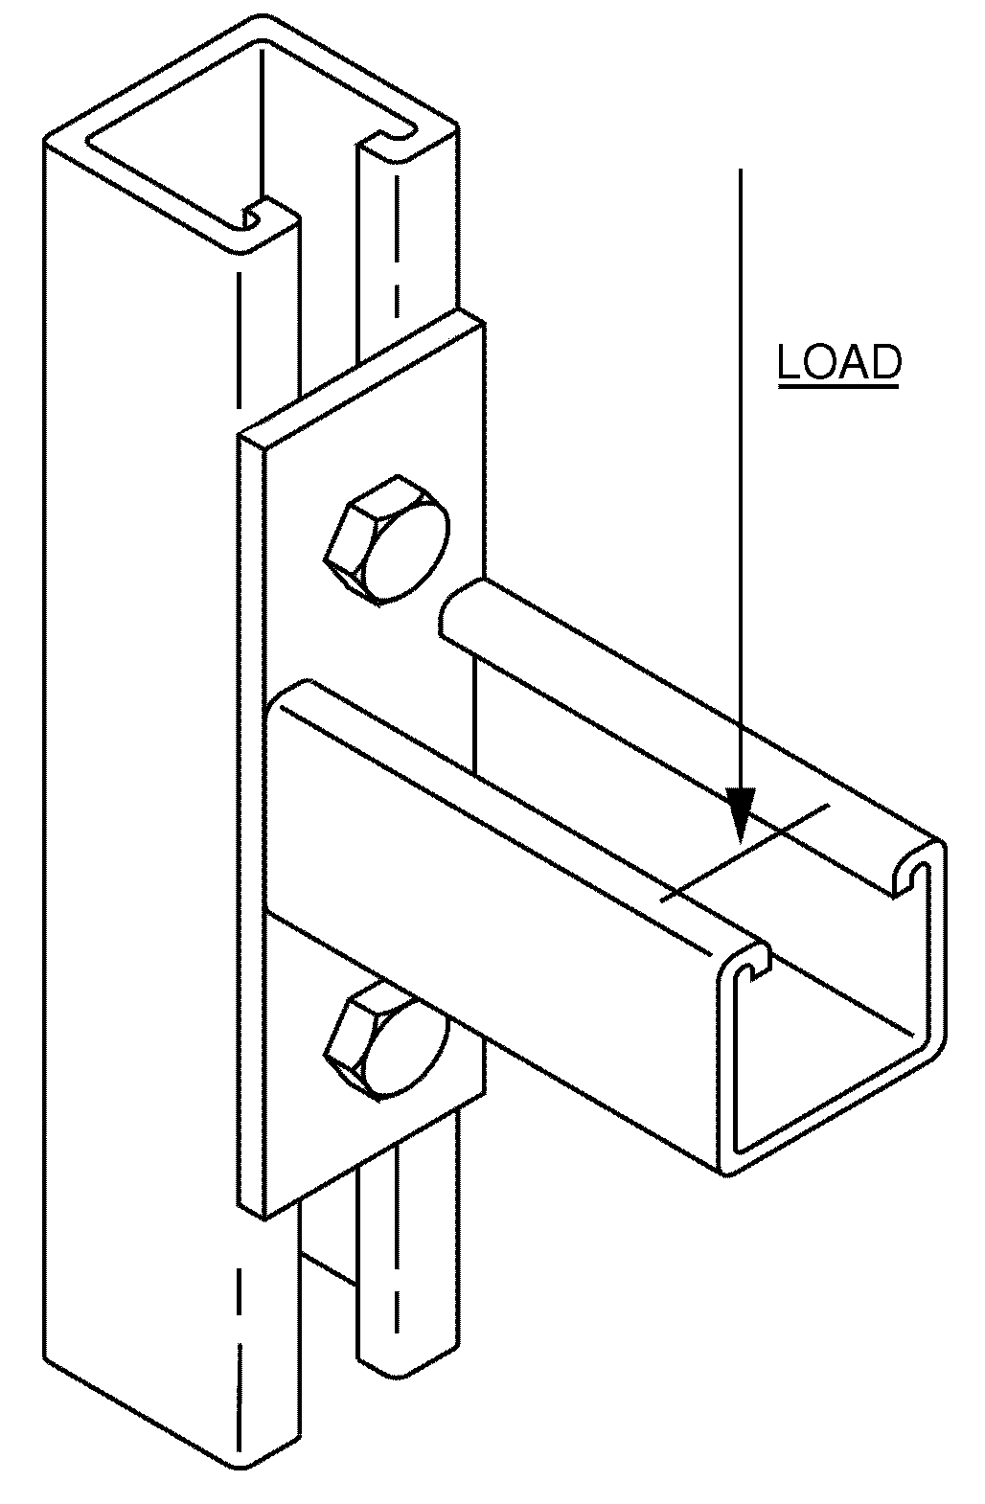

Figure 17

The bracket shall be attached to the slot opening of the channel.

The threaded fasteners shall be inserted and tightened to a torque as given in 9.1.1.

The channel shall be rigidly secured and the test load shall be applied to the bracket as shown in Figure 17.

Failure shall be the lesser of either the point of maximum load where yielding or slipping continues without any increase in the load or where distortion of the part becomes so great as to render the proper performance impossible.

The rate of loading shall not exceed 1/2 inch per minute.

This testing produces a moment, which can be mathematically converted into uniformly distributed load ratings or point load ratings.

NOTE: This test shall be evaluated in accordance with the applicable section of the AISI “Specification for the Design of Cold-Formed Steel Structural Members,” latest edition.

9.1.8 Concrete Insert Pullout Test

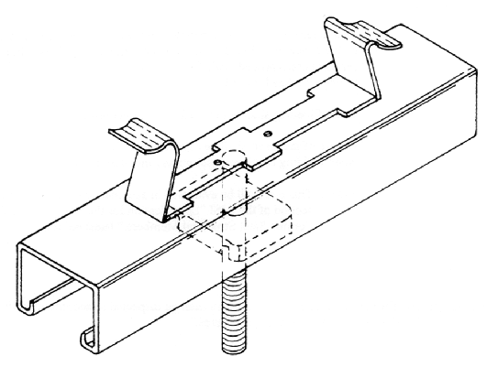
Figure 18

9.1.8.1 Test Specimens

Three identical concrete insert specimens shall be cast individually into three individual concrete slabs of the same dimensions and shall have the following characteristics:

a) The concrete mixture shall be proportioned so that the compression strength will be 2,500 to 3,000 pounds per square inch with a minimum cure time of 28 days.

b) Reinforcing bars may be located between anchors but shall neither be in contact with anchors, nor closer to the surface of the concrete slab than the depth of the insert, including anchors.

9.1.8.2 Test Procedure

Support points for the test slab shall be no closer to the insert than the insert depth including anchors.

9.1.8 (cont.)

Test loads applied to the concrete insert test specimen shall consist of a single concentrated load for a single concentrated load condition and of a series of concentrated loads for longer lengths which are loaded uniformly. See Figure 18.

Rate of loading shall not exceed 1/2 inch per minute.

Failure of the insert shall be established as the point of maximum load when yielding continues without any increase in the load.

NOTE: This test shall be evaluated in accordance with the applicable section of the AISI “Specification for the Design of Cold-Formed Steel Structural Members,” latest edition.

9.2 INSPECTION

Channel, general fittings, accessories, and fasteners shall be inspected in accordance with the manufacturer’s established quality control procedures.
APPENDIX A
BIBLIOGRAPHY OF SOURCES

Aluminum Association

American Iron & Steel Institute (AISI)

American National Standards Institute (ANSI)

American Society for Non-destructive Testing

American Society for Testing and Materials (ASTM)

American Society of Mechanical Engineers (ASME)

American Welding Society (AWS)

General Services Administration (GSA)

Industrial Fasteners’ Institute (IFI)

National Bureau of Standards (NBS)

National Fire Protection Association (NFPA)

Underwriters Laboratories, Inc. (UL)

Society of Automotive Engineers (SAE)

APPENDIX B

METAL FRAMING MANUFACTURERS ASSOCIATION
MEMBER COMPANIES
(Revised 07/16)

Allied Tube and Conduit/ Powerstrut
16100 S. Lathrop Ave.
Harvey, IL 60426

Cooper B-Line
509 West Monroe Street
Highland, IL 62249

Flex-Strut, Inc.
2900 Commonwealth Ave., NE
Warren, OH 44483

G-STRUT
4100 13th St., SW
Canton, OH 44710

Haydon Corporation
415 Hamburg Turnpike
Wayne, NJ 07470

Thomas & Betts Corporation
8155 T&B Boulevard
Memphis, TN 38125

Unistrut
35660 Clinton Drive
Wayne, MI 48184-2091

Wesanco, Inc.
14870 Desman Road
La Mirada, CA 90638

